SIMATS ENGINEERING
Saveetha Institute of Medical and Technical Sciences
ASSESSMENT TOOL 2: SCENARIO-BASED
Cloud Computing and Big Data Analytics
Course Code: CSA15
Item | Details
Course Outcome | CO2: Analyze virtualization architectures to identify performance and security issues in cloud computing environments (BL3)
Assessment Weightage | 20%
Dave’s Taxonomy | Manipulation (Level 2)
Number of Questions | 5
Total Marks | 25
Topics Covered | Scalability, Containers & Multi-cloud, Backup & DR, Hybrid Cloud, High Availability

Student Name / Reg. No: O.Eshanth reddy/1924260199
Signature: esanth
Code of Conduct: I certify that this submission is my original work and that I have adhered to the guidelines specified for this assessment. I understand that any violation of academic integrity rules will result in disciplinary action.

Contents
Section | Topic
Introduction and Common Cloud / Virtualization Foundations | Approach
Question 1: Cloud Video Streaming Platform | Scalability, caching, cost
Question 2: Multi-Cloud Containers for a Fintech Startup | Orchestration, multi-cloud
Question 3: Backup and Disaster Recovery for E-Learning | Backup, RTO / RPO
Question 4: Hybrid Cloud for a Government Agency | Security, IAM, encryption
Question 5: High Availability for a SaaS Provider | Multi-region, monitoring
Overall Summary, Rubric Alignment and References | Conclusion

Introduction and Approach
This document answers the five scenario-based questions of Assessment Tool 2 for the course Cloud Computing and Big Data Analytics (CSA15, CO2). Each answer follows the same structure so that it aligns with the assessment rubric: (1) understanding of the scenario, (2) identification of risks and issues, (3) application of cloud and virtualization concepts through an architecture, (4) justification of the decisions taken, and (5) a clear and organised presentation using diagrams and tables.
Q. | Scenario | Main concepts applied
1 | Media company video streaming migration | CDN, caching, load balancing, auto-scaling, cost optimisation
2 | Fintech containers on multiple clouds | Kubernetes, GitOps, service discovery, autoscaling, multi-cloud trade-offs
3 | E-learning data loss and recovery | Backup, versioning, replication, RTO/RPO, business continuity
4 | Government hybrid cloud | Hybrid architecture, VPN/dedicated link, IAM, encryption, challenges
5 | SaaS multi-region availability | Multi-region active-active, replication, failover, monitoring

Common Cloud and Virtualization Foundations
All five solutions rely on the same underlying principle: virtualization abstracts physical hardware into flexible virtual machines and containers, which lets the cloud provider pool resources and lets customers allocate and release them on demand. Hypervisors (Type-1 such as KVM, Xen, ESXi, Hyper-V) isolate virtual machines from each other, while container engines share one operating-system kernel and isolate processes using namespaces and cgroups. Isolation, resource allocation and live migration are what make elasticity and fault tolerance possible, but they also create the performance and security issues that this course outcome asks us to analyse.
Aspect | Virtual machines | Containers
Isolation | Strong (separate guest OS, hypervisor boundary) | Process-level; shared kernel, weaker boundary
Start-up time | Tens of seconds to minutes | Milliseconds to seconds
Resource overhead | Higher (full OS per VM) | Low (shared OS)
Typical use here | Databases, legacy and regulated workloads (Q3, Q4) | Microservices and scalable web tiers (Q1, Q2, Q5)
Main security concerns | VM escape, hypervisor flaws, VM sprawl, side-channel attacks | Kernel exploits, vulnerable images, misconfigured privileges
Main performance concerns | Noisy neighbours, CPU steal, I/O contention | Resource limits, shared kernel contention, network overlay overhead

Cross-cutting performance and security issues
- Performance: noisy-neighbour interference, over-commitment of CPU/memory, network latency between regions, storage I/O limits, cold starts when scaling.
- Security: shared-responsibility misunderstandings, identity compromise, misconfigured storage, unpatched images, data exposure in transit or at rest, insider threats.
- Mitigations used throughout: resource limits and right-sizing, auto-scaling, caching, encryption (at rest and in transit), IAM with MFA and least privilege, network segmentation, immutable infrastructure, monitoring and regular testing.

Question 1: Cloud Video Streaming Platform

1.1 Scenario Understanding
A media company wants to migrate its video streaming platform to the cloud. The platform must serve millions of concurrent users with minimal buffering. Video streaming is one of the most demanding cloud workloads because it combines three difficult properties at once: very high and unpredictable traffic (spikes during live events or new releases), large payloads (gigabytes of video data per hour of viewing), and strict latency expectations (viewers abandon a stream after only a few seconds of buffering).
The central design problem is therefore not simply “where do we host the servers” but “how do we deliver the same bytes to millions of people from a location close to each of them, without paying for peak capacity all day long.” The answer rests on four pillars: caching/CDN, load balancing, auto-scaling and cost optimisation.
Issue / Risk | Why it matters in this scenario
Traffic spikes | Premieres, live sports and viral content can multiply demand 10x within minutes.
Buffering / latency | Long distance between viewer and origin server causes rebuffering and churn.
Origin overload | If every viewer fetches from the origin, storage and network collapse.
Single points of failure | One failed server, zone or load balancer must not stop playback.
Runaway cost | Egress bandwidth and over-provisioned compute are the largest cost items.
Security / piracy | Content must be protected using DRM, signed URLs and DDoS protection.

1.2 Proposed Cloud Architecture
The proposed design is a layered, horizontally scalable architecture. The viewer’s request is first resolved by DNS and a global traffic manager, then served from the nearest CDN edge location. Only on a cache miss does the request travel through the WAF and the application load balancer to the compute tier, which pulls the video segment from origin object storage.
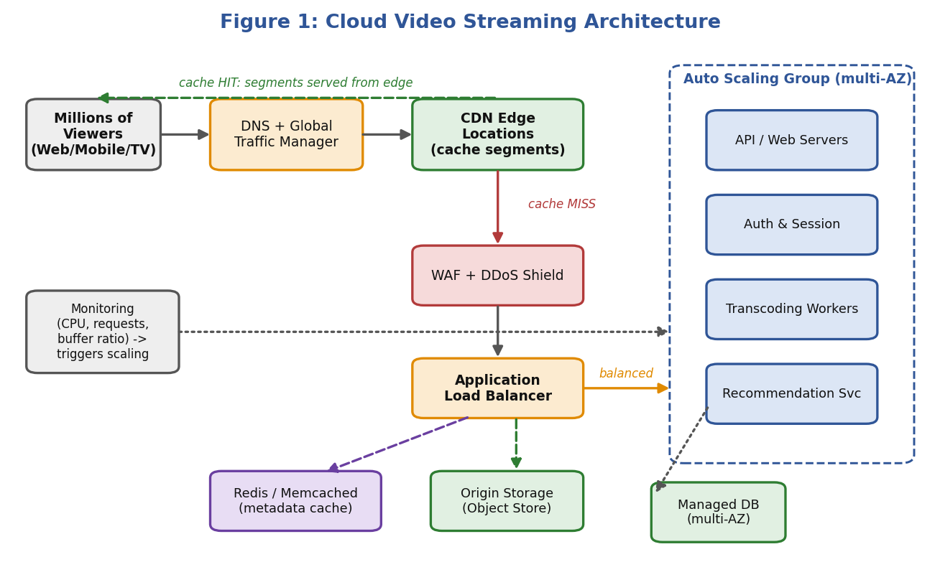
Figure 1: Cloud video streaming architecture with CDN, load balancer and auto-scaling group

Layer-by-layer description
- Client and DNS layer: Viewers use web, mobile and smart-TV apps that implement adaptive bitrate (ABR) streaming (HLS or MPEG-DASH). The player switches between 240p and 4K automatically according to current bandwidth, which is the first defence against buffering.
- CDN edge layer: Video is cut into 2–6 second segments and cached at hundreds of edge locations worldwide. A well-tuned CDN achieves a cache-hit ratio of 90–95%, meaning only 5–10% of requests ever reach the origin.
- Security layer: A web application firewall (WAF) and DDoS shield filter malicious traffic. Signed URLs, token authentication and DRM (Widevine, FairPlay, PlayReady) protect the content.
- Application layer: Stateless microservices (catalogue, authentication, session, recommendations, billing) run in containers or VMs inside an auto scaling group spread across multiple availability zones.
- Media processing layer: Transcoding workers convert uploaded masters into multiple bitrates and formats. This is batch work and can run on cheap spot instances using a queue.
- Data layer: Video files live in highly durable object storage (11 nines of durability). User, subscription and watch-history metadata live in a managed multi-AZ database, with an in-memory cache (Redis/Memcached) in front for hot reads.
- Observability layer: Metrics (CPU, requests per second, rebuffering ratio, start-up time) feed alarms that trigger scaling and alert the operations team.

1.3 Scalability and Caching Techniques

Horizontal scalability
The application tier is designed to be stateless: session data is kept in a distributed cache or token (JWT), not in the memory of a particular server. Because any instance can handle any request, capacity can be increased by simply adding more identical instances (scale-out) instead of buying a bigger machine (scale-up). Scale-out has no upper ceiling, supports fault tolerance and allows capacity to shrink again when demand drops.

Multi-level caching
Cache level | Technology | What is cached and benefit
Client / browser | Player buffer, local storage | Pre-fetches next segments; hides short network drops.
CDN edge | CloudFront / Akamai / Cloud CDN | Video segments, thumbnails, manifests; serves 90%+ of traffic close to the viewer.
Regional / mid-tier cache | CDN origin shield | Collapses many edge misses into one origin request; protects origin.
Application cache | Redis / Memcached | Catalogue, user profile, recommendations; avoids repeated database queries.
Database cache | Read replicas, query cache | Offloads read-heavy workload from the primary database.

Other scalability techniques
- Database scaling: read replicas for reads, sharding by user ID for writes, and managed NoSQL (DynamoDB / Cosmos DB) for watch-history.
- Asynchronous processing: queues (SQS, Kafka, Pub/Sub) decouple upload and transcoding from the user-facing path so spikes do not slow playback.
- Pre-warming / pre-positioning: popular titles and upcoming premieres are pushed to edge caches before release so the first wave of viewers gets cache hits.

1.4 How Load Balancing and Auto-Scaling Ensure Smooth Streaming

Load balancing
A load balancer is the traffic controller that spreads incoming requests across many healthy servers. In this design, two levels are used. Global load balancing (DNS latency routing or anycast) sends each viewer to the nearest healthy region or edge. Application load balancing (Layer 7) distributes API and session requests across instances in different availability zones.
- Health checks: unhealthy instances are removed from rotation automatically within seconds, so viewers are never routed to a failed server.
- Algorithms: least-outstanding-requests or round-robin for APIs; consistent hashing for cache servers so that the same video segment is always requested from the same cache node.
- Connection draining: when scaling in, in-flight streams are allowed to finish before an instance is terminated.
- TLS offloading: the load balancer terminates HTTPS, freeing CPU on application servers.

Auto-scaling
Auto-scaling adds or removes instances automatically according to rules, so that capacity follows demand. Three policy types are combined:
- Target-tracking: keep average CPU at 60% or request count per instance at a fixed target. This is the default, always-on policy.
- Scheduled scaling: increase capacity ahead of known events (weekend premieres, cricket finals, season releases) so there is no cold-start delay.
- Predictive scaling: machine-learning forecasts based on historical patterns provision capacity before the load arrives.
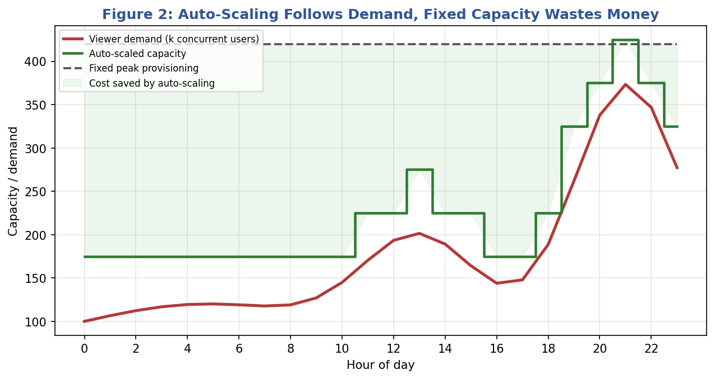
Figure 2: Auto-scaling capacity follows demand, while fixed provisioning wastes money
Figure 2 shows why auto-scaling matters. Fixed capacity must be sized for the highest peak and stays idle the rest of the day; auto-scaled capacity tracks the demand curve, saving the shaded area while still absorbing the evening peak.
How the pieces work together during a viral premiere
1. Demand jumps; the CDN absorbs most requests as cache hits.
2. Misses and API calls reach the load balancer, which spreads them across all healthy instances.
3. CPU and request metrics cross the threshold; the auto scaling group launches new instances within 1–3 minutes (faster with warm pools).
4. New instances pass health checks and join the load balancer automatically.
5. The ABR player lowers the bitrate briefly if bandwidth is limited, so playback continues rather than stalls.
6. After the event, scale-in policies remove surplus instances and the bill falls.

1.5 Cost Optimisation Strategies
For streaming, the largest costs are data transfer (egress), compute and storage. Because these workloads run at very high volume, even small percentage savings are significant.
Strategy | How it is applied | Expected effect
Right-sizing | Analyse utilisation and move instances to the smallest type that meets the target; use ARM/Graviton where possible. | 10–30% compute saving
Reserved instances / Savings Plans | Commit 1–3 years for the always-on baseline capacity (databases, core API). | Up to 40–70% vs on-demand
Spot instances | Run transcoding and batch analytics on spare capacity with checkpointing and queue retries. | Up to 70–90% vs on-demand
Auto-scaling (scale-in) | Release capacity during troughs; schedule down-scaling at night. | Avoids paying for idle servers
CDN optimisation | Increase cache TTLs, use origin shield, negotiate committed-volume CDN pricing. | Fewer origin fetches and lower egress
Storage tiering | Move older or rarely watched titles from standard to infrequent-access/archive tiers using lifecycle rules. | 40–60% storage saving
Efficient encoding | Use per-title encoding and modern codecs (H.265/AV1) to cut bitrate without losing quality. | 20–40% less bandwidth
FinOps governance | Tagging, budgets, anomaly alerts, monthly cost reviews per team. | Prevents surprise bills

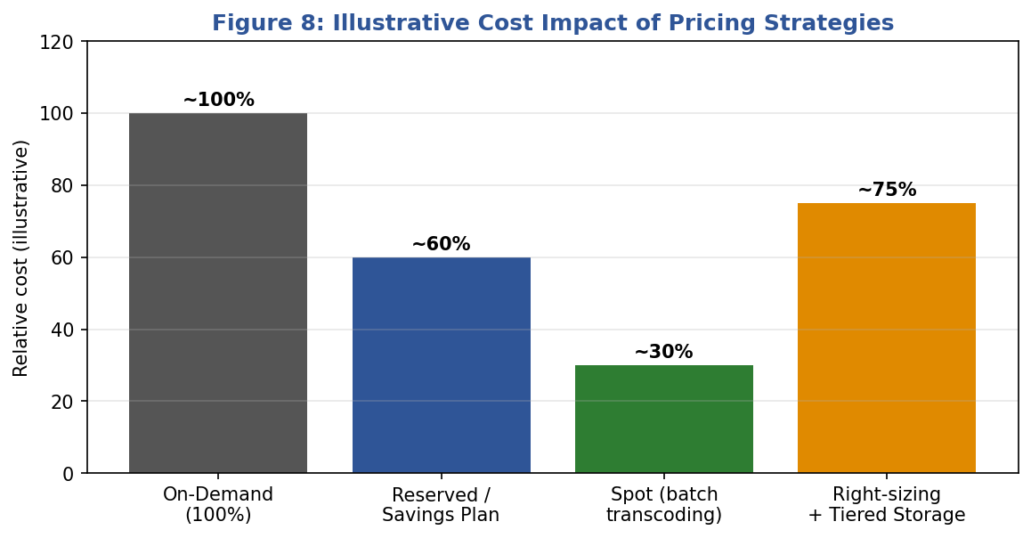
Figure 8: Illustrative cost impact of different pricing and optimisation strategies

1.6 Justification and Conclusion
The CDN-first design is chosen because the cheapest and fastest byte is the one served from a nearby cache; it simultaneously reduces latency (less buffering), origin load (fewer servers) and egress cost. Stateless services behind a load balancer with auto-scaling are chosen because they give elastic capacity without manual intervention, and multi-AZ deployment removes single points of failure. Finally, a blend of reserved, on-demand and spot capacity matches the pricing model to the workload’s predictability. Together these decisions deliver smooth streaming for millions of concurrent users at a sustainable cost.

Question 2: Multi-Cloud Containers for a Fintech Startup

2.1 Scenario Understanding
A fintech startup is deploying containerised applications on multiple cloud providers (for example AWS, Azure and Google Cloud). Their problems are inconsistency between environments and difficulty managing deployments. Each provider has its own networking model, load balancers, IAM, logging and deployment tools, so the same application can behave differently in each place. For a financial business this is risky: regulatory audits, security patching, uptime and data residency all demand predictable, repeatable operations.
Challenge | Consequence
Configuration drift between clouds | “Works on AWS but fails on Azure” incidents; slow debugging.
Manual or provider-specific deployments | Slow releases, human error, no audit trail.
Different networking / IAM / logging per provider | Inconsistent security posture and compliance gaps.
Service-to-service communication across clouds | Hard-coded IPs break; latency and failure handling are unclear.
Uneven scaling | Some clusters over-provisioned, others overloaded at peak.
Skills and tooling overhead | Team must learn three sets of tools.

2.2 Proposed Solution: Kubernetes-Based Multi-Cloud Strategy
The proposed solution is to standardise on containers + Kubernetes as the common runtime layer, managed through GitOps. Kubernetes abstracts the underlying cloud: whether the cluster runs on EKS, AKS or GKE, a deployment manifest means exactly the same thing. All desired state is stored in Git, so every cluster is continuously reconciled to match what the repository says.
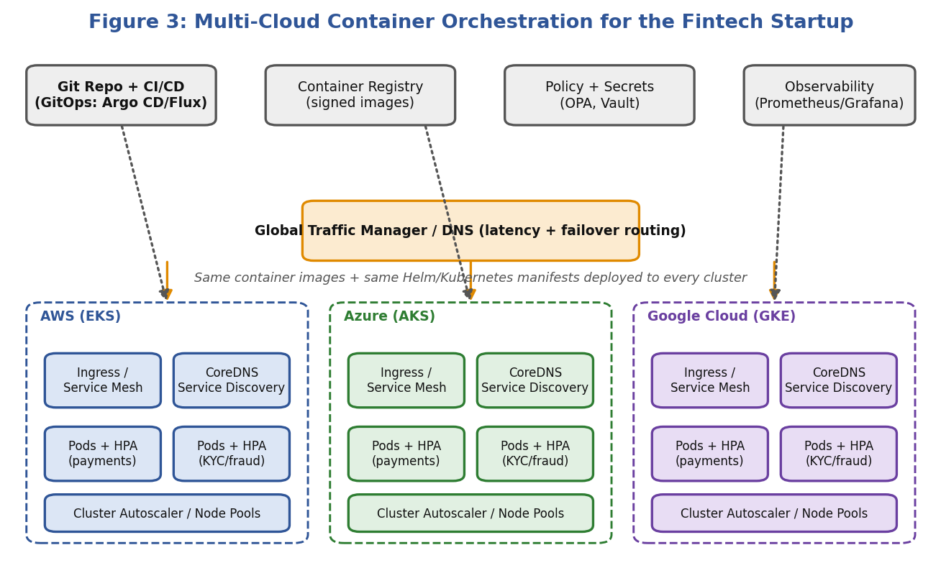
Figure 3: Multi-cloud container orchestration using Kubernetes and GitOps

Key components of the solution
- Containerisation: each microservice (payments, KYC, fraud detection, notifications) is packaged as an immutable image with all dependencies, giving identical behaviour everywhere. Images are built once in CI, scanned for vulnerabilities and signed.
- Managed Kubernetes in each cloud: EKS, AKS and GKE reduce operational burden because the provider runs the control plane. Alternatively, a unified platform such as Anthos, Azure Arc or Rancher can manage all clusters from one console.
- GitOps (Argo CD / Flux): Git is the single source of truth. A pull request is the only way to change production; the controller applies changes to every cluster, detects drift and corrects it automatically. Rollback is a simple Git revert.
- Infrastructure as Code: Terraform (or Crossplane) provisions clusters, networks and IAM identically; Helm charts or Kustomize overlays handle per-cloud differences.
- CI/CD pipeline: build → unit tests → image scan → sign → push to registry → update manifest → progressive rollout (canary or blue-green).
- Policy and secrets: Open Policy Agent / Kyverno enforce rules (no root containers, only signed images); HashiCorp Vault or cloud KMS manage secrets consistently.
- Global traffic management: a DNS-based or anycast global load balancer routes users to the nearest healthy cluster and fails over automatically.

Deployment workflow
- Developer commits code; CI builds and tests the container image.
- Image is scanned (Trivy / Snyk), signed and pushed to a registry replicated across clouds.
- The manifest repository is updated with the new image tag through a pull request and approval.
- Argo CD in each cluster detects the change and rolls out gradually (canary 5% → 25% → 100%).
- Prometheus metrics are compared with SLOs; if error rate rises, the rollout is aborted and rolled back automatically.

2.3 Service Discovery and Scaling

Service discovery
In a container environment, pods are created and destroyed constantly and their IP addresses change, so services cannot rely on fixed addresses. Kubernetes solves this with Services and CoreDNS: each service gets a stable virtual IP and DNS name (for example payments.prod.svc.cluster.local) and the platform load-balances across the healthy pods behind it using readiness probes.
- Within a cluster: CoreDNS plus ClusterIP services; headless services for stateful workloads.
- Across clusters and clouds: a service mesh (Istio, Linkerd) or Cilium Cluster Mesh with multi-cluster service discovery, or HashiCorp Consul, allows a service in AWS to call a service in Azure by name, with mutual TLS, retries, timeouts and circuit breaking built in.
- External traffic: Ingress controllers or Gateway API with a global load balancer and health checks.

Scaling
Scaling type | Mechanism | Use in fintech scenario
Horizontal Pod Autoscaler (HPA) | Adds/removes pods based on CPU, memory or custom metrics (requests/sec, queue depth). | Payment API scales on salary-day and festival-sale peaks.
Vertical Pod Autoscaler (VPA) | Adjusts pod CPU/memory requests. | Right-sizes fraud-scoring pods.
Cluster Autoscaler / Karpenter | Adds or removes worker nodes when pods cannot be scheduled. | Provides capacity for pod growth without manual node management.
KEDA (event-driven) | Scales on Kafka lag or queue length, down to zero. | Batch reconciliation and statement jobs.
Global (multi-cloud) scaling | Traffic manager shifts load between clouds based on health and cost. | Overflow to another cloud if one region is saturated.

Efficiency is achieved by setting resource requests and limits correctly, using pod disruption budgets to keep minimum replicas during scaling, and using separate node pools (on-demand for payments, spot for non-critical batch).

2.4 Benefits and Risks of the Multi-Cloud Deployment Model
Benefits | Risks
Avoids vendor lock-in: workloads can move if pricing or terms change. | Higher complexity: more tools, more integration points, more things to fail.
Resilience: an outage at one provider does not stop the business. | Skills gap: engineers need expertise in several platforms.
Best-of-breed services: e.g., use one provider’s AI/analytics and another’s database. | Inconsistent security / IAM: each cloud has different identity and logging models, widening the attack surface.
Regulatory and data-residency flexibility: place data in the country required by RBI or other regulators. | Data transfer cost and latency: egress fees and cross-cloud network delay.
Negotiating power and cost optimisation: choose cheapest region/provider for each workload. | Lowest-common-denominator effect: avoiding provider-specific features may sacrifice performance or convenience.
Global reach: use the provider with the best presence in each market. | Compliance overhead: audits must cover every provider and prove consistent controls.

Risk mitigation
- Standardise on Kubernetes, Terraform and one observability stack (Prometheus, Grafana, OpenTelemetry) so tooling is the same everywhere.
- Centralise identity through a single identity provider with SSO and MFA, federated into each cloud.
- Keep stateful data in one primary location with replication, and keep stateless services multi-cloud, to limit cross-cloud data transfer.
- Use FinOps tools (Kubecost, CloudHealth) for unified cost visibility.
- Run regular game-day exercises that simulate the loss of one cloud.

2.5 Justification and Conclusion
Kubernetes with GitOps is recommended because it converts a different environment per cloud into a single, declarative platform. It delivers consistency (same image, same manifest), speed (automated pipelines), and safety (policy enforcement and automatic rollback), which are all essential in a regulated fintech setting. Service discovery through DNS and a service mesh removes dependence on IP addresses, while HPA, cluster autoscaling and global traffic management make scaling efficient. The multi-cloud model brings resilience and flexibility, but its complexity must be controlled by strong standardisation and automation; for a startup the sensible path is to begin with one primary cloud and one secondary for disaster recovery, expanding only as business needs justify.

Question 3: Backup and Disaster Recovery for an E-Learning Platform

3.1 Scenario Understanding
An e-learning platform lost data because someone accidentally deleted it in the cloud. This is one of the most common real-world data-loss causes; it is human error, not hardware failure. The important lesson is that high availability and replication alone are not backup: if a file is deleted, a replica faithfully deletes it too. The platform therefore needs a layered strategy combining versioned storage, point-in-time backups, cross-region copies and a tested recovery plan.
Data at risk | Impact if lost
Student records, enrolments, grades, certificates | Legal and reputational damage; students cannot prove completion.
Course videos, PDFs, assignments | Expensive to recreate; instructors lose work.
Quiz submissions and progress data | Learners lose progress; exam disputes.
Payment and subscription data | Revenue loss and compliance issues.
Configuration, code and databases | Platform cannot be rebuilt quickly.

Threats to be covered include accidental deletion, malicious insiders, ransomware, application bugs that corrupt data, hardware or availability-zone failures, and full region outages.

3.2 Proposed Solution Design
The design follows the 3-2-1-1 rule: at least three copies of data, on two different storage types, one copy off-site (another region), and one copy that is immutable/offline. It uses cloud-native services so that backup is automated, policy-driven and requires no manual effort.
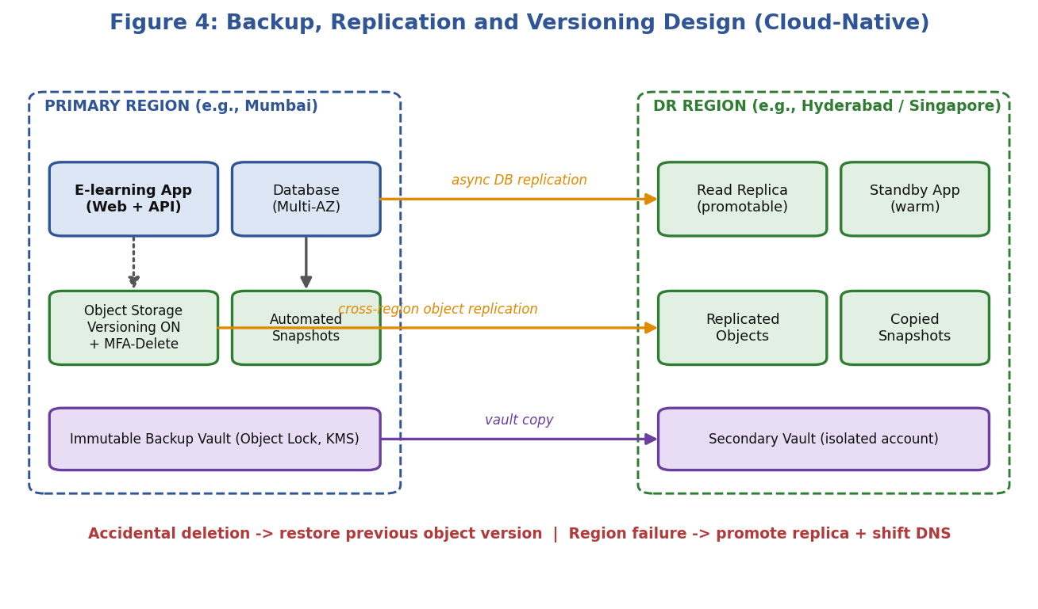
Figure 4: Backup, replication and versioning design across primary and DR regions

A. Versioning (protects against accidental deletion)
- Enable object versioning on all storage buckets. When a file is overwritten or deleted, the old version is kept; a delete only adds a delete marker that can be removed to restore the file instantly.
- Enable MFA-Delete or equivalent so permanent deletion of versions requires a second factor.
- Use lifecycle rules to expire old non-current versions after, for example, 90 days, keeping costs under control.
- Enable soft-delete / recycle bin for databases, file shares and VMs, with a retention period of 7–30 days.

B. Backup (protects against corruption, ransomware and bugs)
- Use a managed backup service (AWS Backup, Azure Backup, Google Backup and DR) with a central backup policy: hourly incremental, daily full, weekly and monthly retention.
- Enable point-in-time recovery (PITR) for databases so the database can be restored to any second within the retention window (e.g., 35 days).
- Store backups in an immutable vault (Object Lock / WORM) so even an administrator or attacker cannot delete them before the retention period ends.
- Encrypt backups with customer-managed keys (KMS) and restrict access with least-privilege IAM; keep the backup account separate from the production account.

C. Replication (protects against zone/region failure)
- Within a region: multi-AZ database with synchronous replication; storage automatically replicated across zones.
- Cross-region: asynchronous replication of the database (read replica / global database) and cross-region replication of the object store to a DR region.
- Cross-account copy of backups into an isolated account so a compromised production account cannot erase every copy.

D. Infrastructure and application recovery
- Use Infrastructure as Code (Terraform / CloudFormation) and container images so the application stack can be recreated in the DR region within minutes.
- Choose a DR pattern that matches business need (see table below).
DR pattern | Description | RTO | RPO | Cost
Backup & restore | Data is restored from backups into new infrastructure after a disaster. | Hours | Hours | Low
Pilot light | Core data replicated and minimal servers kept ready; scale up on failure. | 10s of minutes | Minutes | Low–Med
Warm standby | Scaled-down full copy always running in DR region. | Minutes | Seconds–minutes | Medium
Active-active | Full capacity in two or more regions simultaneously. | Near zero | Near zero | High

For an e-learning platform a warm standby for the database and application plus backup & restore for archived media is a balanced choice: students tolerate a few minutes of downtime, but they cannot tolerate lost grades.

3.3 How RTO and RPO Are Achieved
Recovery Point Objective (RPO) is the maximum amount of data (measured in time) the business can afford to lose. Recovery Time Objective (RTO) is the maximum time the service can be unavailable before the impact becomes unacceptable. They are set by the business and then achieved through technical design.
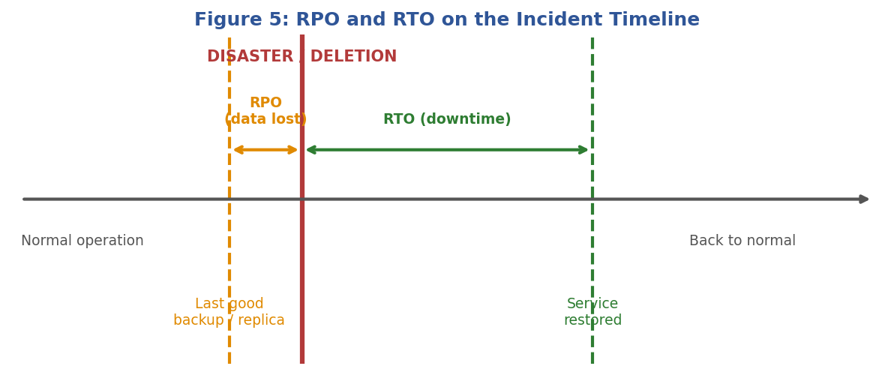
Figure 5: RPO and RTO shown on an incident timeline
Data / Service | Target | How it is achieved | Technology
Student records & grades DB | RPO ≤ 5 min, RTO ≤ 30 min | Continuous replication + PITR; automated promotion of the replica. | Multi-AZ DB, cross-region read replica, PITR
Course content (objects) | RPO ≈ 15 min, RTO ≤ 1 hr | Versioning + cross-region replication; CDN cache serves content during recovery. | Versioned buckets, replication rules, CDN
Application tier | RTO ≤ 30 min | Pre-built images and IaC; auto-scaling group in DR region scaled up on failover. | Terraform, AMIs/containers, Auto Scaling
Logs, analytics, archives | RPO ≤ 24 hr, RTO ≤ 24 hr | Daily snapshots copied to DR vault; restored on demand. | Backup service, archive tier

Techniques that lower RPO
- Higher backup frequency and continuous replication (log shipping / change-data-capture).
- Synchronous replication across AZs for zero data loss within a region.
- Transaction logs archived every few minutes for point-in-time recovery.

Techniques that lower RTO
- Pre-provisioned or warm standby resources in the DR region.
- Automated failover (health-check-driven DNS failover, runbooks as code) instead of manual steps.
- Regular restore testing so that the process is known to work and well rehearsed.
- Smaller, faster-restoring backups using incremental snapshots and tiering.

3.4 Steps to Ensure Business Continuity During Failures
Phase | Action | Details
1 | Prepare (Business Impact Analysis) | Classify systems (critical / important / non-critical); agree RTO/RPO; document dependencies and owners.
2 | Protect | Implement versioning, backups, replication, immutability, encryption and least-privilege access as designed above.
3 | Detect | Monitoring and alarms for deletion spikes, backup job failures, replication lag, health-check failures.
4 | Declare & communicate | Incident commander declares a disaster per defined criteria; status page and student/instructor notification starts.
5 | Recover | For deletion: restore previous version or PITR. For region failure: promote replica, scale up DR stack, switch DNS.
6 | Validate | Run smoke tests: login, course playback, assignment submission, grade view; verify data integrity.
7 | Resume & review | Return to normal operation (fail-back), then run a post-incident review and update runbooks.

Immediate response for the accidental-deletion incident
1. Stop further changes: restrict the account or bucket and capture the audit log (CloudTrail / Activity Log) to identify what was deleted and by whom.
2. Restore objects by removing delete markers or restoring the previous versions; restore database tables using point-in-time recovery into a new instance and copy back only the lost rows.
3. Verify with checksums and sample content checks; notify affected users.
4. Prevent recurrence: remove broad delete permissions, require approvals/MFA for destructive actions, add deletion-protection flags and alerts.

Testing and governance
- Perform restore drills at least quarterly and a full DR failover test twice a year; measure actual RTO and RPO against targets.
- Keep runbooks in version control and available offline; train staff and define on-call responsibilities.
- Review backup coverage automatically using tag-based policies so that new resources are never left unprotected.

3.5 Justification and Conclusion
The accidental deletion occurred because the platform relied on a single copy and had no recovery path. The proposed layered approach fixes this: versioning gives instant undo, backups with PITR protect against corruption, immutable vaults protect against malicious deletion and ransomware, and cross-region replication protects against infrastructure disasters. By assigning clear RTO and RPO values to each data class and testing recovery regularly, the platform can guarantee continuity of learning for its students at a cost proportionate to the value of each dataset.

Question 4: Hybrid Cloud for a Government Agency

4.1 Scenario Understanding
A government agency wants the agility and cost advantages of the public cloud, but some applications and data are subject to compliance, sovereignty and security requirements that force them to stay on-premises. The agency therefore needs a hybrid cloud: sensitive workloads (citizen identity records, tax, defence, health, law-enforcement data) remain in a private on-premises environment, while non-sensitive workloads (public websites, open-data portals, citizen self-service front-ends, analytics on anonymised data) run in the public cloud.
Requirement | Implication for the design
Data classification | Every dataset must be labelled (public / internal / confidential / secret) and placed accordingly.
Data sovereignty & residency | Data may not leave national borders; the public cloud region must be in-country.
Secure connectivity | Traffic between environments must never traverse the open internet unprotected.
Strong identity & access control | Only authorised officials can reach sensitive systems; all access is audited.
Regulatory compliance | Standards such as ISO 27001, MeitY empanelment, CERT-In guidelines, DPDP Act.
Continuity | Services should keep running if the link or one environment fails.

4.2 Hybrid Architecture with Secure Communication
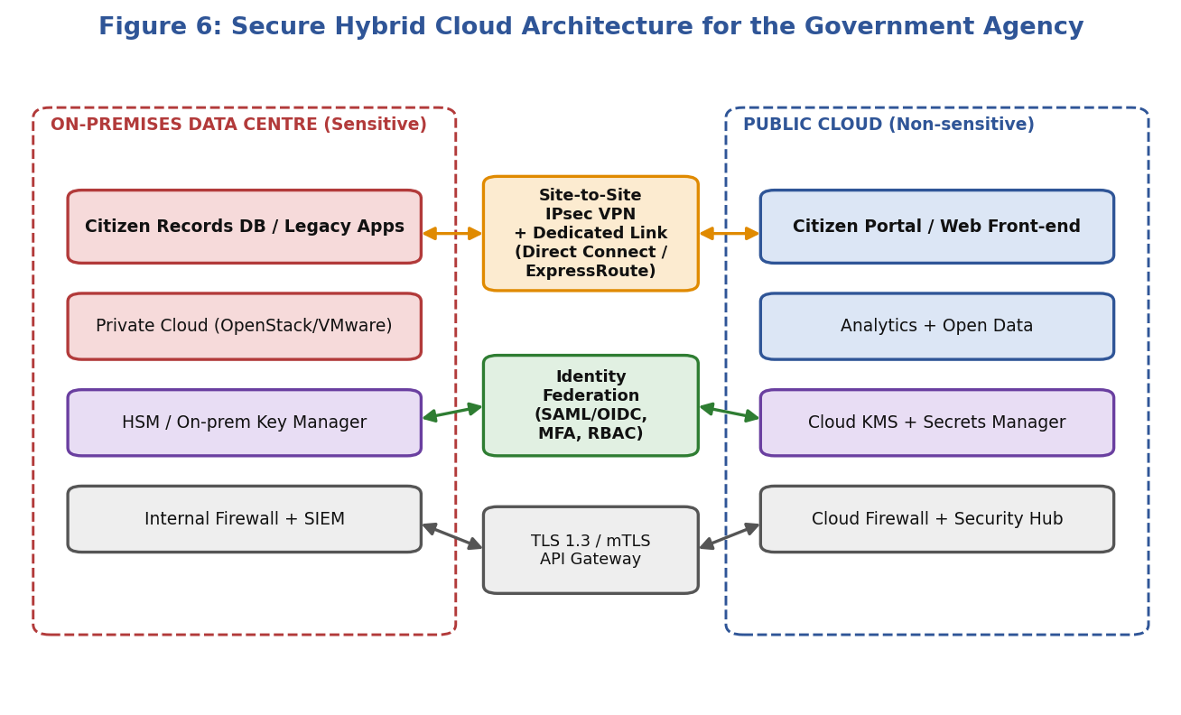
Figure 6: Secure hybrid cloud architecture connecting on-premises and public cloud

Components
- On-premises data centre / private cloud: hosts citizen databases and legacy applications, virtualised with VMware or OpenStack, protected by internal firewalls, IDS/IPS and a SIEM for monitoring. Keys for sensitive data live in a hardware security module (HSM).
- Public cloud (government-community or in-country region): hosts the citizen portal, content delivery, analytics and development/test environments. Built as a landing zone with separate accounts/subscriptions, guardrails and central logging.
- Connectivity layer: a combination of a dedicated private link (AWS Direct Connect, Azure ExpressRoute, Google Interconnect or NIC/NKN leased line) for predictable low latency, with an IPsec site-to-site VPN as an encrypted backup path. Traffic is never exposed to the public internet.
- Network segmentation: separate VPCs/VNets and subnets for each tier (web, application, data); security groups and network ACLs follow default-deny; a DMZ and API gateway mediate every cross-boundary call.
- Zero-trust principles: every request is authenticated, authorised and encrypted, regardless of whether it originates inside or outside the network (“never trust, always verify”).
- Data-flow rule: the public cloud front-end never stores sensitive records; it calls APIs exposed by the on-premises systems through the API gateway, receiving only the minimum data needed (tokenised or masked).

Secure communication techniques
Technique | Purpose | Implementation
IPsec VPN / dedicated link | Encrypted, private path between sites | Redundant tunnels over two carriers, BGP routing, failover
TLS 1.2/1.3 and mutual TLS | Protect application-layer traffic and authenticate both ends | Certificates issued by a private CA; service mesh enforces mTLS
API gateway | Single controlled entry point, throttling and validation | OAuth 2.0 tokens, rate limits, schema validation
Web application firewall + DDoS protection | Block OWASP Top-10 attacks | WAF in front of the public portal
Private endpoints | Access cloud services without public IPs | PrivateLink / Private Endpoint / Private Service Connect
Network monitoring | Detect anomalies and intrusion | Flow logs, IDS/IPS, SIEM correlation

4.3 Identity Management and Encryption

Identity and access management (IAM)
- Federated identity: one authoritative identity provider (on-premises Active Directory / government IdP) is federated to the cloud using SAML 2.0 or OpenID Connect. Officials sign in once (SSO) and the same identity is valid in both environments; there are no separate cloud passwords to manage.
- Multi-factor authentication (MFA): mandatory for all users, and phishing-resistant (FIDO2 / hardware token / smart card) for administrators and access to sensitive systems.
- Role-Based and Attribute-Based Access Control: roles map to job functions; policies also consider attributes such as department, device compliance, location and time.
- Least privilege and separation of duties: no standing admin rights; use Privileged Access Management with just-in-time elevation, session recording and approval workflows.
- Lifecycle management: automated joiner/mover/leaver processes so access is removed immediately when staff change roles or leave.
- Service identities: workloads use short-lived credentials/managed identities rather than long-lived keys.
- Audit: all authentication and administrative actions are logged immutably and forwarded to the on-premises SIEM.

Encryption
State of data | Approach | Details
Data at rest | AES-256 encryption for databases, disks, object storage and backups | Sensitive data stays on-prem; any cloud copy uses customer-managed keys.
Data in transit | TLS 1.3, IPsec, mTLS between services | Reject weak ciphers; enforce HSTS and certificate rotation.
Data in use | Confidential computing / secure enclaves for processing sensitive data in cloud | Optional, for high-sensitivity analytics.
Field-level protection | Tokenisation, masking and format-preserving encryption | Aadhaar-style identifiers replaced by tokens in cloud systems.

Key management
- Use BYOK/HYOK (bring-your-own-key or hold-your-own-key): master keys are generated and stored in the agency’s on-premises HSM (FIPS 140-2 Level 3), and the cloud KMS uses them only to wrap data keys.
- Separate key custodians from system administrators; rotate keys automatically (e.g., annually) and revoke instantly if a compromise is suspected.
- Maintain key backup and recovery procedures, since losing a key means permanent data loss.

4.4 Challenges in Managing Hybrid Cloud Environments
Challenge | Description | Mitigation
Integration complexity | Different platforms, APIs and versions between legacy on-premises systems and cloud services. | Use standard APIs, middleware/iPaaS, containers and an integration layer.
Consistent security & compliance | Policies can diverge between environments, leaving gaps. | Policy-as-code, unified CSPM, regular audits and common baselines.
Unified visibility & monitoring | Separate tools provide fragmented views. | Central observability and SIEM across both environments.
Latency and bandwidth | Chatty applications across the link degrade performance. | Place tightly coupled components together; cache; use dedicated links.
Data governance and sprawl | Unclear where each dataset lives and who copied it. | Data classification, catalogue, DLP and tagging.
Skills shortage | Teams need both traditional IT and cloud skills. | Training, certifications, managed service partners.
Cost management | Duplicate infrastructure and unpredictable egress fees. | FinOps practices, budgets, chargeback, rightsizing.
Vendor and procurement constraints | Government rules limit provider choices and speed. | Use empanelled providers and framework contracts.
Disaster recovery across environments | Different recovery mechanisms on each side. | Single DR plan covering both with tested runbooks.
Single link as point of failure | If the interconnect fails, the two halves cannot communicate. | Redundant circuits with different carriers and routes.

4.5 Justification and Conclusion
The hybrid design is justified because it honours legal constraints (sensitive data stays on-premises under the agency’s direct control) while still allowing citizens to benefit from the scalable, always-available services of the public cloud. Private dedicated links with IPsec and mTLS protect data in motion; federated identity with MFA and PAM gives uniform and auditable access; and agency-controlled keys in an HSM keep ultimate control of encryption in the agency’s hands. The challenges of integration, visibility and skills are real but manageable through automation, unified monitoring and strict governance. This balanced approach lets the agency modernise at its own pace without compromising security or compliance.

Question 5: High Availability and Fault Tolerance for a SaaS Provider

5.1 Scenario Understanding
A SaaS provider must keep its application running even if an entire cloud region goes down. Regions are normally independent, but whole-region failures do happen because of power or network failures, natural disasters, cascading software faults or provider configuration errors. Since SaaS customers pay for continuous service and sign SLAs (for example 99.99% availability, equal to about 52 minutes of downtime a year), a regional outage without a prepared plan can mean broken contracts, penalties and customer churn.
Concept | Meaning in this scenario
High availability (HA) | Design that minimises downtime by removing single points of failure (multiple servers, zones, load balancers).
Fault tolerance | System continues to operate correctly, with no or only brief disruption, when components or a whole region fail.
RTO / RPO | Targets for how fast the service returns and how much data may be lost (here near-zero for both).
Blast radius | The extent of a failure; multi-region design limits it to a fraction of customers.

Availability target | Downtime per year | Typical architecture
99.9% (“three nines”) | 8.76 hours | Single region, multi-AZ
99.99% (“four nines”) | 52.6 minutes | Multi-region warm standby
99.999% (“five nines”) | 5.26 minutes | Multi-region active-active with automation

5.2 Multi-Region Deployment Strategy
The recommended strategy is active-active deployment across at least two regions, each of which is itself spread over at least two or three availability zones. Both regions serve live traffic; each is sized to handle the entire load (N+1 capacity) if the other fails.
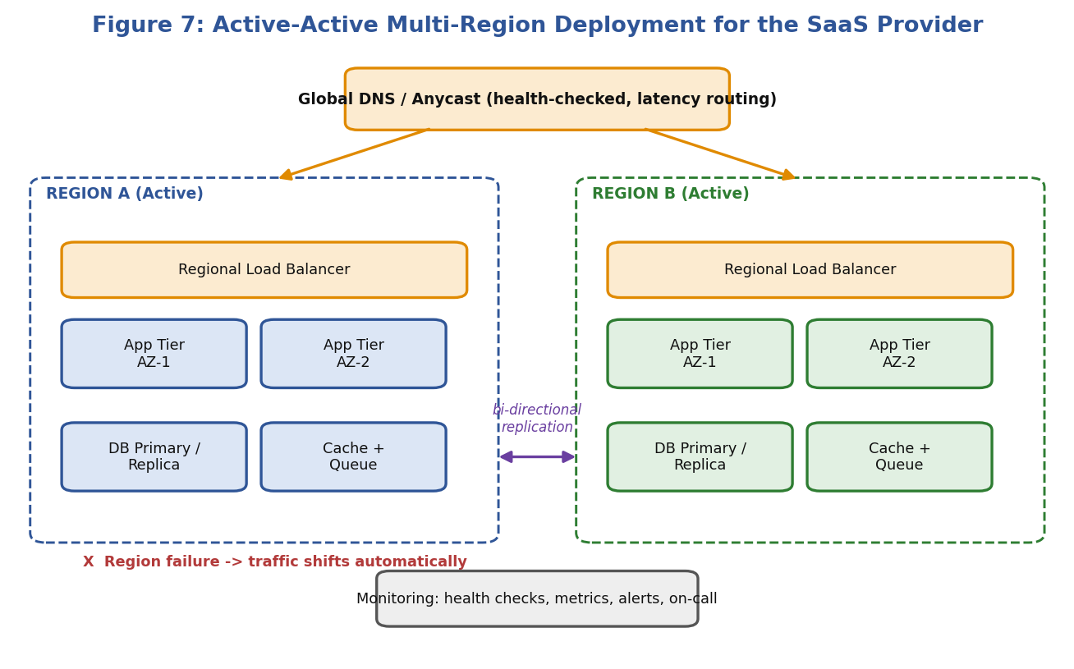
Figure 7: Active-active multi-region deployment with global traffic routing

Deployment patterns compared
Pattern | How it works | Failover time | Data loss | Cost
Active-passive (cold) | Second region only has backups; infrastructure built on demand. | Hours | Minutes–hours | $
Active-passive (warm) | Scaled-down standby; scales up on failover. | Minutes | Seconds–minutes | $$
Active-active | Both regions serve traffic simultaneously. | Seconds | Near zero | $$$

Design principles
- Stateless application tier: no local state, so any region can serve any request. Sessions kept in distributed stores or tokens.
- Everything as code: identical stacks deployed to every region with Terraform and CI/CD, avoiding configuration drift.
- Global entry point: DNS-based (Route 53 / Azure Traffic Manager / Cloud DNS) or anycast (Global Accelerator, Azure Front Door, Cloud Load Balancing) routing with health checks; latency-based routing during normal operation.
- Cell-based / tenant-sharding option: customers are divided into cells so that a failure impacts only one cell, reducing blast radius.
- Capacity planning: each region reserves enough headroom (or has auto-scaling) to absorb the traffic of a failed peer; pre-warmed capacity avoids a cold-start delay.
- Independent dependencies: each region has its own queues, caches, secrets and DNS records, so a failed regional service does not cascade to the other region.
- Resilience patterns in code: timeouts, retries with exponential backoff and jitter, circuit breakers, bulkheads, idempotent APIs and graceful degradation (e.g., read-only mode).

5.3 Data Replication and Failover Configuration

Data replication
Data is the hardest part of multi-region design because of the CAP trade-off: during a network partition, a system must choose between consistency and availability. The right choice depends on the data type.
Data type | Replication method | Consistency | Examples
Relational transactional data | Primary region with cross-region read replica (async), or global database with multi-writer / write-forwarding | Strong in primary; eventual in replicas | Aurora Global DB, Azure SQL geo-replication, Cloud Spanner
User/session/profile data | Multi-master NoSQL with automatic conflict resolution | Eventual (tunable) | DynamoDB Global Tables, Cosmos DB, Cassandra
Object / file data | Cross-region replication with versioning | Eventual (seconds–minutes) | S3 CRR, Azure GRS, GCS dual-region
Cache | Independent per region, re-built from the database | Not replicated | Redis, Memcached
Events and queues | Replicated topics / mirrored streams | At-least-once | Kafka MirrorMaker, EventBridge global endpoints
Configuration and secrets | Replicated secrets store and Git-based config | Strong via pipeline | Secrets Manager replicas, Vault

- Conflict handling: use last-writer-wins with logical clocks, CRDTs or per-tenant home-region ownership to prevent two regions from editing the same record.
- Replication lag monitoring: alarm when lag exceeds the RPO (e.g., >5 seconds).
- Backups still required: replication does not protect from logical corruption or deletion, so snapshots and PITR continue in each region (see Question 3).

Failover mechanisms
Component | Configuration
Health checks | Route 53 / Traffic Manager checks a deep health endpoint (/health) that verifies app, database and dependencies from multiple locations every 10–30 seconds; failure threshold of 2–3 checks.
DNS failover | Low TTL (30–60 s) records with failover or weighted routing; unhealthy region removed automatically. Anycast removes DNS caching delays.
Load balancer layer | Regional load balancers perform instance-level health checks and connection draining.
Database failover | Automatic promotion of a replica to primary (typically 1–2 minutes) with fencing of the old primary to avoid split-brain; applications use cluster endpoints rather than IP addresses.
Application behaviour | Clients retry with backoff; sticky sessions avoided; stateless pods restart in the healthy region.
Automation | Runbook-as-code (Step Functions, Lambda, Ansible) executes failover; human approval only for risky actions such as database promotion if policies require.
Fail-back | After recovery, re-synchronise data, gradually shift traffic (10% → 50% → 100%) and verify before restoring the original topology.

Failover sequence
- Region A’s health checks start failing (network outage or service failure).
- Global traffic manager marks Region A unhealthy after the failure threshold is reached.
- New requests are routed to Region B within seconds; Region B’s auto-scaling expands capacity.
- The database in Region B is promoted (if it was a replica); writes continue.
- Alerts notify the on-call engineer; the status page is updated automatically.
- When Region A recovers, data is synchronised and traffic returned gradually.

5.4 Monitoring and Alerting for Proactive Issue Detection
Resilience is only real if failures are noticed quickly. Monitoring must itself be reliable, so it should be hosted outside the failure domain (a separate region or third-party service) and combine technical, user-experience and business views.

Observability pillars
- Metrics: CPU, memory, latency percentiles (p50/p95/p99), error rates, saturation, queue depth, replication lag (Prometheus, CloudWatch, Azure Monitor).
- Logs: centralised, structured and searchable (ELK/OpenSearch, Splunk, Cloud Logging) with retention for audit.
- Traces: distributed tracing (OpenTelemetry, Jaeger, X-Ray) to find which service in a request chain is slow or failing.
- Synthetic monitoring: scripted user journeys (login, create record, checkout) executed every minute from several geographic locations to detect problems before customers do.
- Real-user monitoring: page-load times and errors from actual browsers and devices.
Signal (Golden Signals) | Example alert | Action
Latency | p95 response time > 800 ms for 5 min | Scale out; investigate slow dependency
Traffic | Requests drop > 40% vs same time last week | Check routing / DNS / outage upstream
Errors | 5xx error rate > 2% for 3 min | Page on-call; consider automatic rollback
Saturation | CPU > 80% or DB connections > 90% | Trigger auto-scaling; raise capacity
Replication lag | Lag > 10 s | Warn; > 60 s page; check network between regions
Health-check failure | Region health check fails twice | Automatic failover and incident creation
SLO burn rate | Error budget consumed 10x faster than allowed | Escalate; freeze deployments

Alerting strategy
- Alert on symptoms, not just causes: prioritise customer-visible indicators (SLOs) to reduce noise.
- Severity levels: P1 (page immediately, region impact), P2 (respond within an hour), P3 (ticket).
- Escalation: PagerDuty/Opsgenie rotations with escalation to a secondary engineer and manager if not acknowledged.
- Anomaly detection: machine-learning baselines catch unusual patterns that static thresholds miss.
- Runbooks linked from alerts: each alert carries clear diagnostic steps and remediation.
- Dashboards and status page: per-region and global dashboards; automated public status page for transparency.

Proactive practices
- Chaos engineering: regularly inject failures (terminate instances, block a region, add latency) using tools such as AWS Fault Injection Service or Chaos Mesh to verify that failover works.
- Game days and DR drills: simulated region loss at least twice a year, measuring actual RTO and RPO.
- Capacity and trend analysis: forecast growth to avoid saturation.
- Post-incident reviews: blameless postmortems feed back into design and alert tuning.

5.5 Justification and Conclusion
An active-active multi-region design is selected because it is the only approach that meets the requirement of continuing to operate when a region disappears, with failover measured in seconds rather than hours. Stateless services, infrastructure as code and global routing make regions interchangeable; carefully chosen replication models for each data type balance consistency and availability; and automated health-check-driven failover removes dependence on human reaction time. Comprehensive monitoring, SLO-based alerting and regular chaos testing ensure problems are detected early and the recovery process is proven rather than assumed. The extra cost of duplicate capacity is justified by avoided SLA penalties, customer trust and business continuity.

Overall Summary and Conclusion
The five scenarios look different on the surface but share a common design philosophy: eliminate single points of failure, automate everything, protect data in layers, and measure continuously. The table below summarises the recommended solution for each scenario.
Q. | Key design decision | Primary benefit | Main trade-off
1 | CDN-first architecture with load balancer and auto-scaling group | Low latency, minimal buffering, elastic capacity | CDN and egress cost; complexity of cache invalidation
2 | Kubernetes + GitOps across AWS, Azure and GCP | Consistency, fast and safe deployments, no lock-in | Operational complexity; skills and cross-cloud costs
3 | Versioning + immutable backups + cross-region replication, with tested RTO/RPO | Recovery from deletion, ransomware and disasters | Storage cost; need for regular drills
4 | Hybrid cloud with private link/VPN, federated IAM and HSM-held keys | Compliance with cloud agility | Integration and governance effort
5 | Active-active multi-region with automated failover and SLO-based alerting | Survives loss of a whole region | Higher cost; data-consistency design

Rubric Alignment
Rubric criterion | How this submission addresses it
Understanding of scenario (20%) | Every answer begins by restating the scenario and listing its constraints and needs.
Identification of risks / issues (20%) | Each answer has a risk or challenge table (e.g., traffic spikes, drift, accidental deletion, compliance, region failure).
Application of concepts (25%) | Virtualization, containers, load balancing, replication, IAM, encryption and monitoring are applied in architectures and diagrams.
Decision justification (20%) | A justification section explains why each design choice was preferred over the alternatives.
Clarity (15%) | Consistent structure, headings, tables, and eight figures make the answer easy to follow.

In conclusion, cloud architectures succeed when business requirements (availability, security, compliance and cost) are translated into concrete technical mechanisms (caching, orchestration, replication, encryption, automation) and when those mechanisms are monitored and tested continuously. The solutions presented in this document demonstrate how the course outcome CO2 (analysing virtualization architectures to identify performance and security issues) can be applied to real-world scenarios.

References and Further Reading
- NIST SP 800-145: The NIST Definition of Cloud Computing.
- AWS Well-Architected Framework (Reliability, Security, Cost Optimization and Performance Efficiency pillars).
- Microsoft Azure Well-Architected Framework and Cloud Adoption Framework.
- Google Cloud Architecture Framework and Site Reliability Engineering (SRE) books.
- Kubernetes documentation: Services, Autoscaling and Cluster Architecture.
- Armbrust et al., “A View of Cloud Computing”, Communications of the ACM, 2010.
- Cloud Security Alliance: Security Guidance for Critical Areas of Focus in Cloud Computing.

